Penguin and Comet Frostbite
Tred Avon Yacht Club | November 05, 2022

Penguin (9 boats)
Series Standing - 4 races scored

Regatta results last updated: Saturday, November 05, 2022 1:11:30 PM CDT
Pos | Sail | Boat | Skipper | Yacht Club |  | 1 | 2 | 3 | 4 |  | Total | Pos
1 | 9694 | Otter B | Charles Krafft /  Cairn Krafft | SSA |  | 2 | 2 | 2 | 2 |  | 8 | 1
2 | 9660 | Rex | Jonathan Bartlett /  Annie Bartlett | Annapolis Yacht Club |  | 1 | 1 | 1 | 10/DNS |  | 13 | 2
3 | 9632 | Spax | Jane Delashmutt /  Sewall Cox | MRYC |  | 3 | 6 | 4 | 1 |  | 14 | 3
4 | 9730 | Evelyn | Jeffrey Cox /  Ian Cox | TAYC |  | 6 | 5 | 3 | 3 |  | 17 | 4
5 | 9662 | Against The Grain | Sandy McAllister /  Athena Arnold | Tred Avon Yacht Club |  | 5 | 3 | 6 | 5 |  | 19 | 5
6 | 9575 |  | Philip Logan | TAYC |  | 4 | 7 | 7 | 4 |  | 22 | 6
7 | 9576 | Looseseal | Andrew Eyring | AYC |  | 7 | 4 | 5 | 10/DNF |  | 26 | 7
8 | 8241 | Humble Pie | Michael Baugh /  Heneage Baugh | CYC/TAYC |  | 8 | 8 | 8 | 10/DNS |  | 34 | 8
9 | 9747 | Buttercup | Elizabeth Principe /  Lia Schutt | Cambridge Yacht Club |  | 9 | 10/DNF | 10/DNC | 10/DNS |  | 39 | 9

The TAYC Frostbite was anything but, with temperatures ashore in the mid-70’s. The water was a bit cooler and the 10 – 15 kt southerly breeze kept two on the rail for the upwind legs. The single-handers had a tricky time balancing the boat off the wind, as the rolling swells made for some interesting saves. Jonathan and Annie Bartlett led the way with two bullets in the first two races and a photo finish bullet in race 3, but Jonathan had a stomach bug that cut their day short. Jane Delashmutt sailing with Sewall Cox in SPAX won the last race. Jeff Cox, sailing with his son Ian, recovered from a rogue wave dislodging the rudder just after the start of race 4, to finish the regatta strong with two 3rds. Sandy McAllister, sailing with Athena Arnold finished fifth, ahead of single-handers Philip Logan, sailing the Class-owned boat, 9575, and Andrew Eyring, in his first appearance since acquiring 9576. Michael Baugh sailing with his son Heneage completed 3 races, but decided to head in before race 4 as the wind continued to build. Elizabeth Principe, sailing with Lia Schutt caught a wave wrong and rolled on the downwind leg of race 2, ending their day on the water. Hats of to Philip Logan and Zak Samih for jumping in the water to help rescue Elizabeth’s boat, which had turtled and was proving difficult to right.
Thanks to Ken Davis (PRO) and RC crew for running a great regatta, and Ed Cassidy with help from Zak Samih in the crash boat.
Wil Keyworth was on hand to provide documentation of the event. His photo gallery is available at 11-5-2022 Oxford Penguin Regatta - Will Keyworth (smugmug.com)
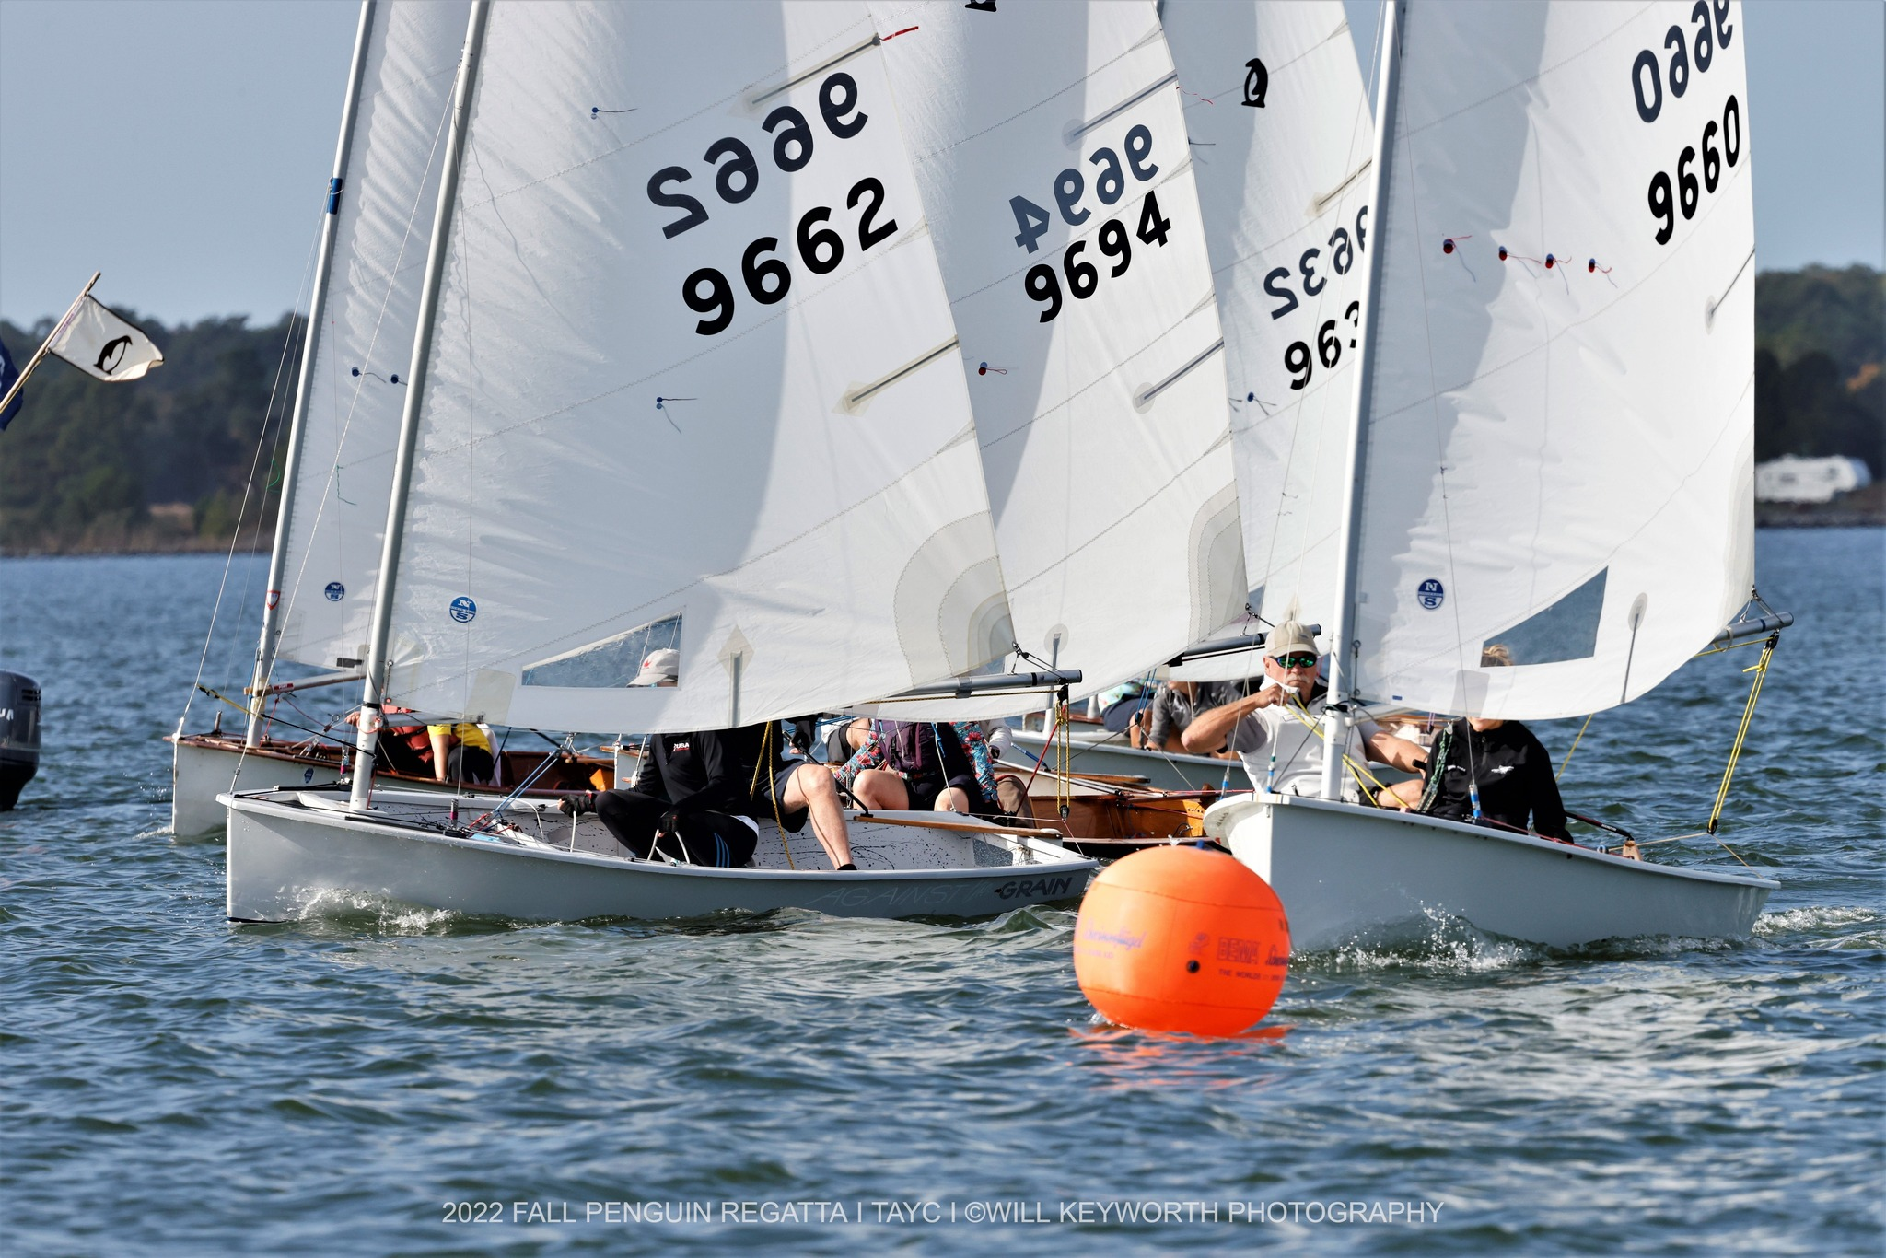
Jonathan and Annie Bartlett (9660) going for a pin end start. (Photo by Wil Keyworth)
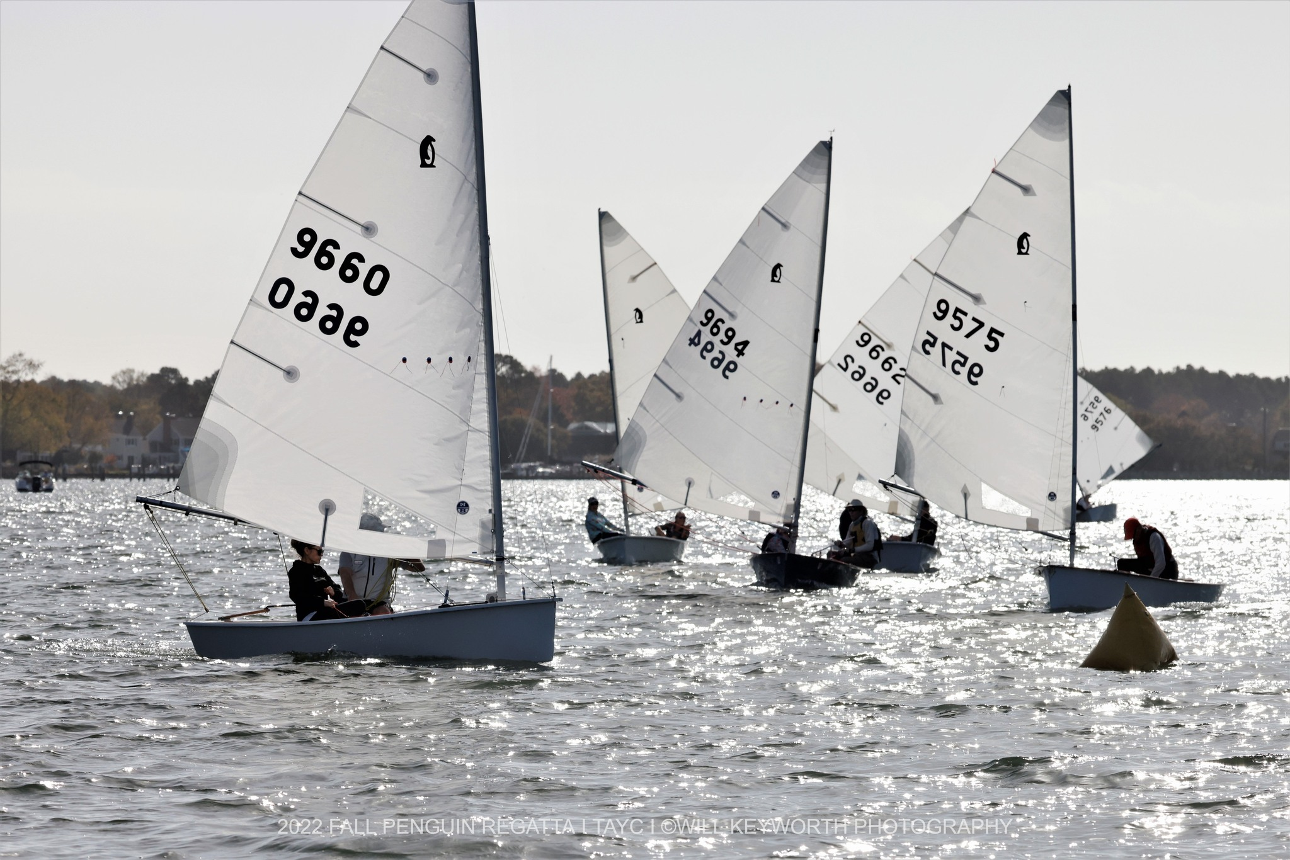
The short courses kept racing close. (Photo by Wil Keyworth)
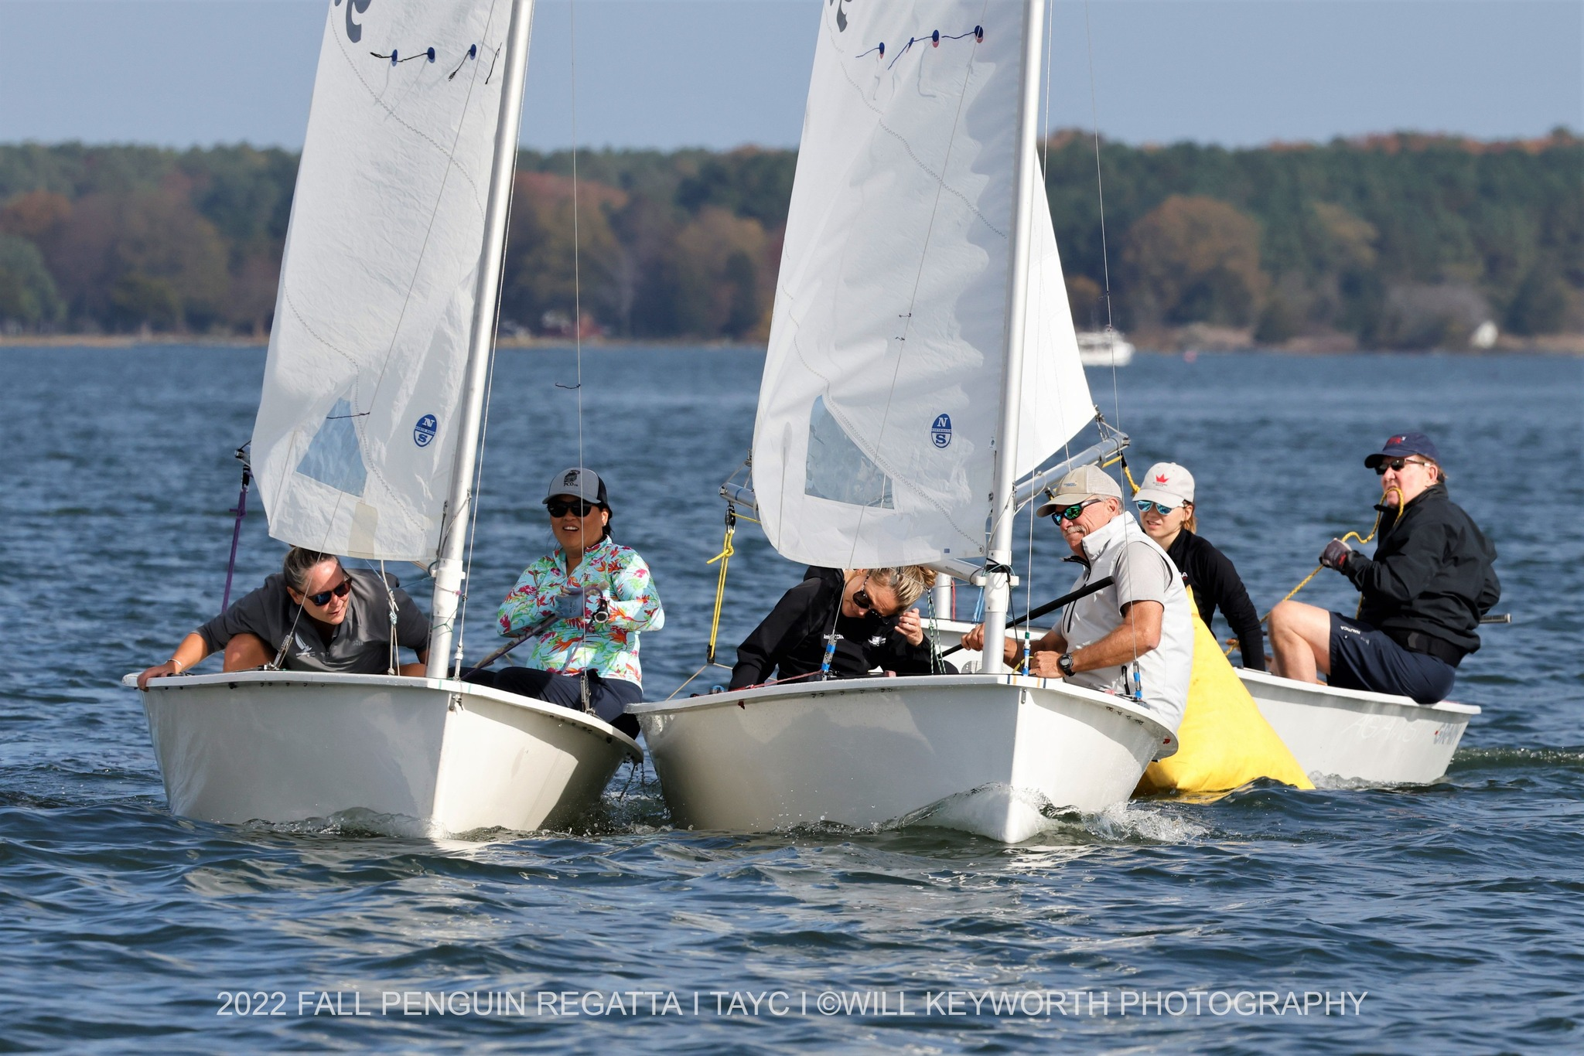
Did we say close? Jane Delashmutt making sure JB doesn’t take too much room at the mark. (Photo by Wil Keyworth)
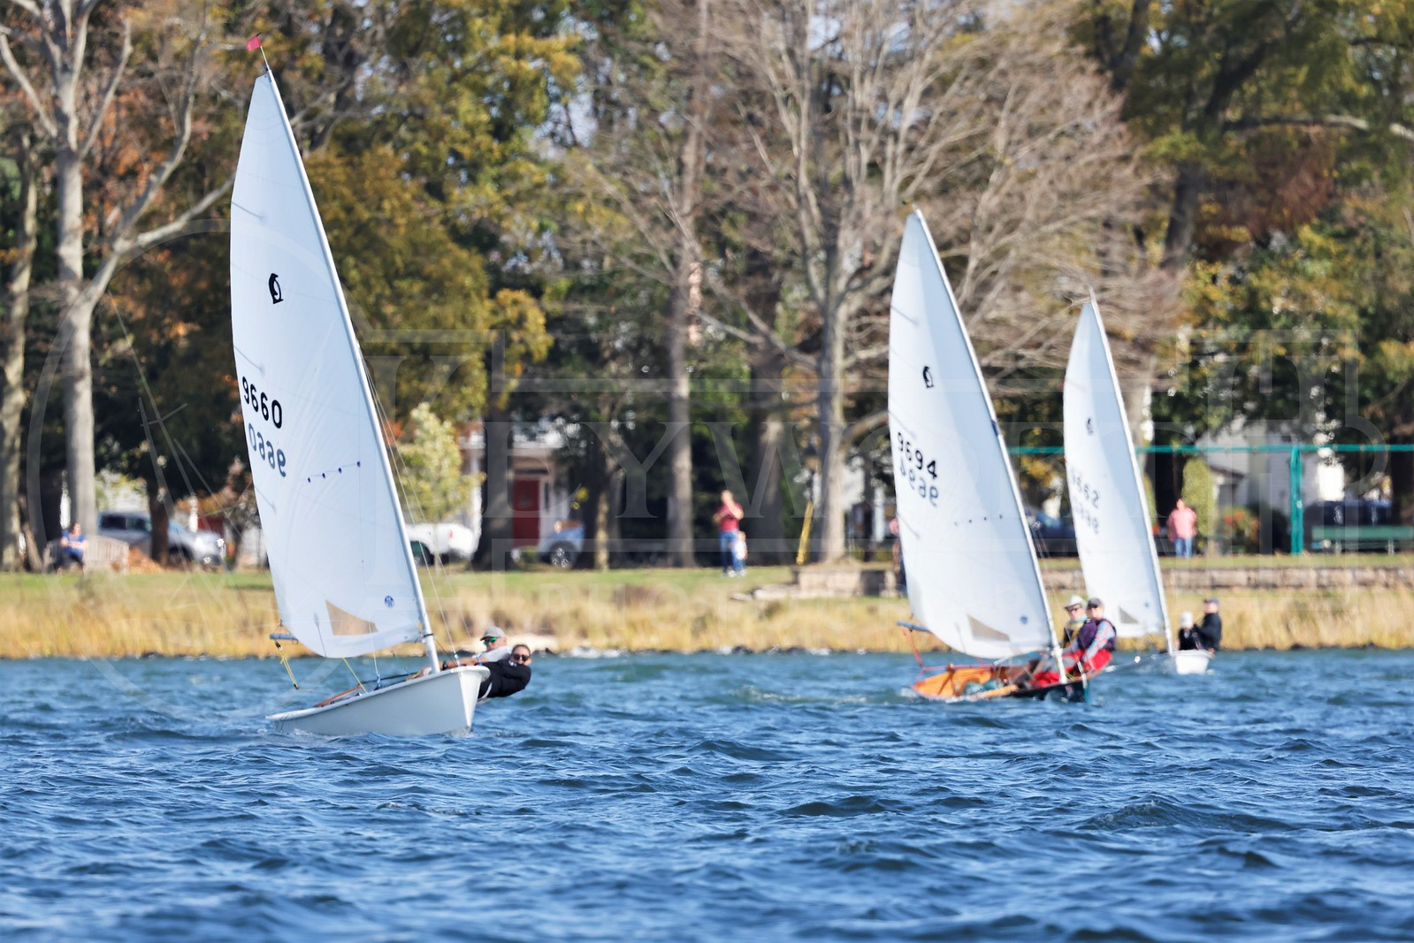
Sailing just off the Oxford town park, made for good spectator viewing. (Photo by Wil Keyworth)
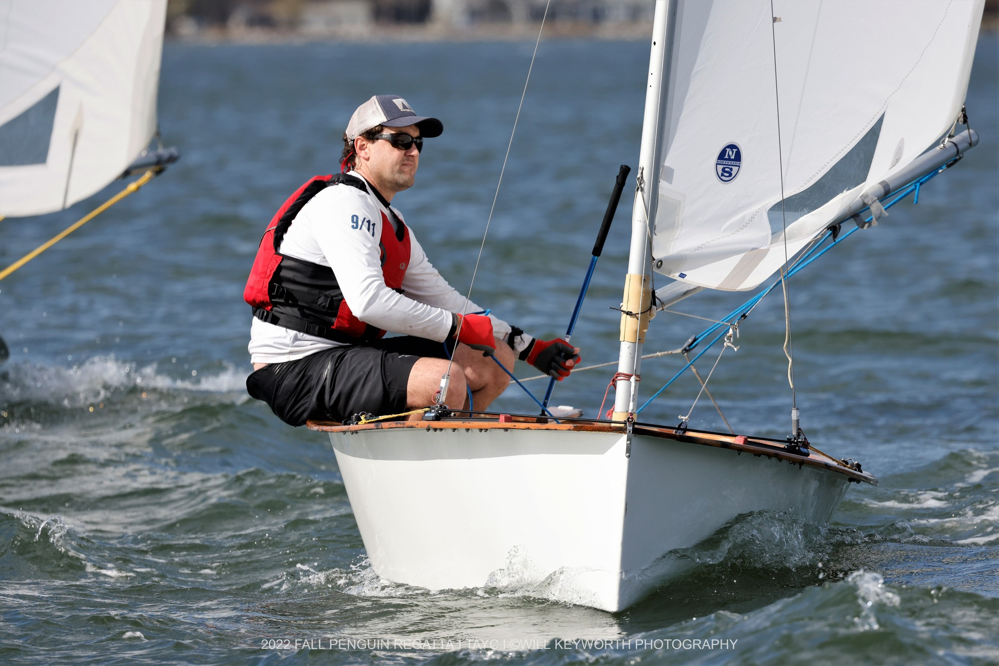
Andrew Eyring keeping the boat flat, sailing solo. (Photo by Wil Keyworth)
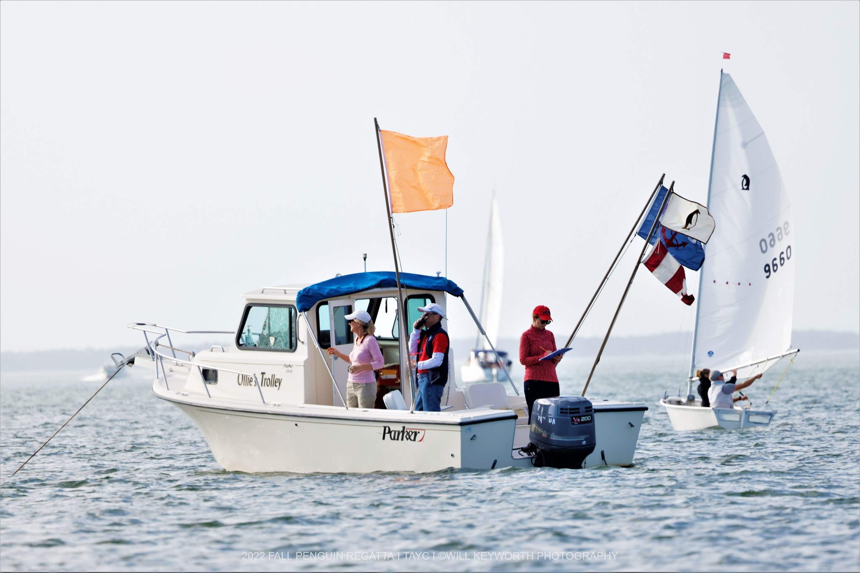
PRO Ken Davis, dealing with a dragging anchor line on the committee boat, had to do extra work to keep the line square. (Photo by Wil Keyworth)
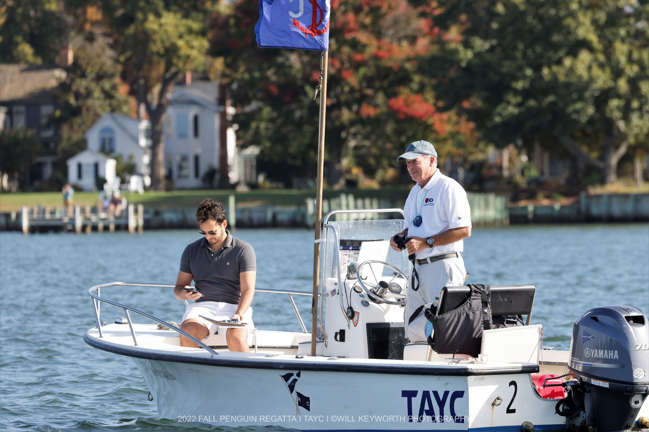
Ed Cassidy and Zak Samih patrolling the race course. (Photo by Wil Keyworth)
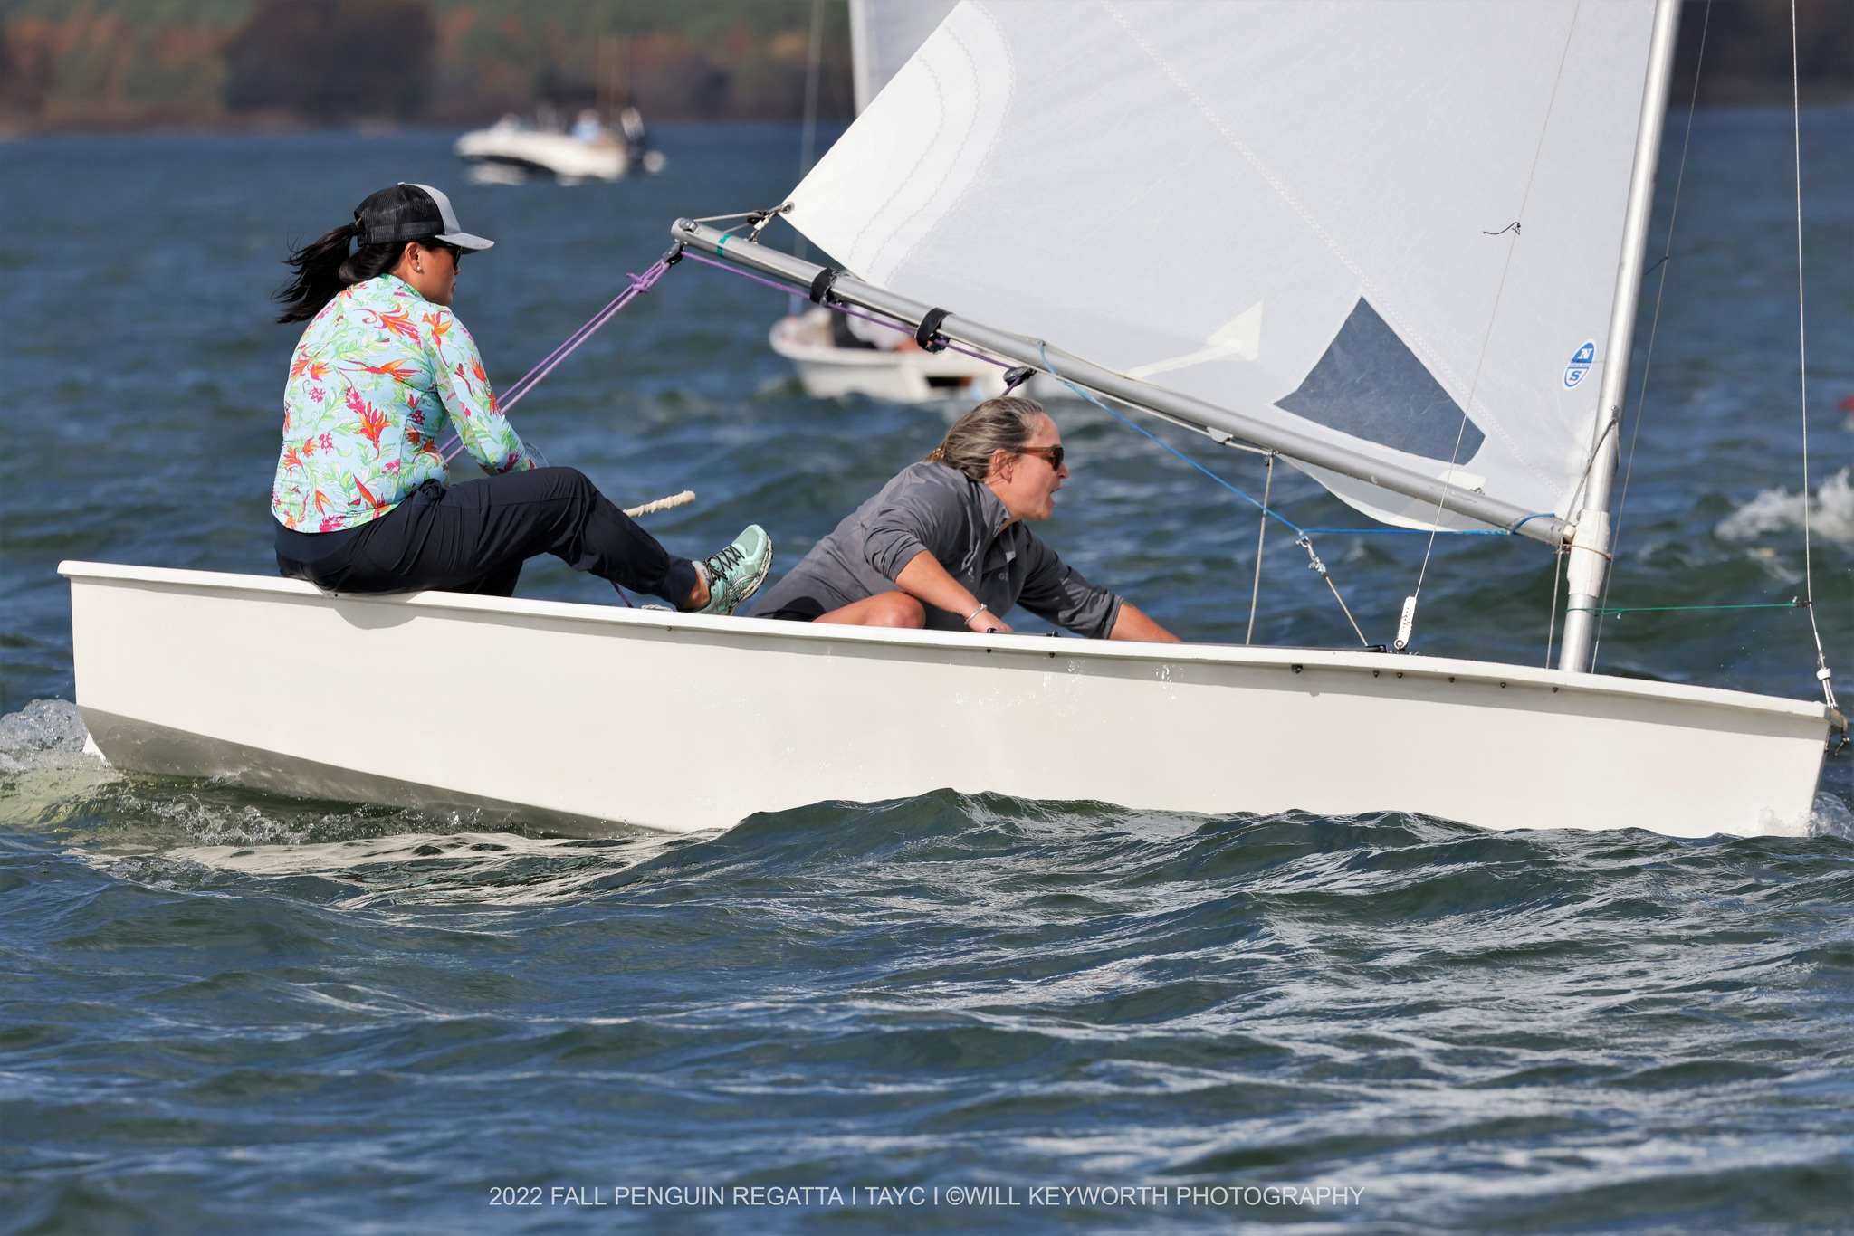
Jane and Sewall – action at the weather mark. (photo by Wil Keyworth)
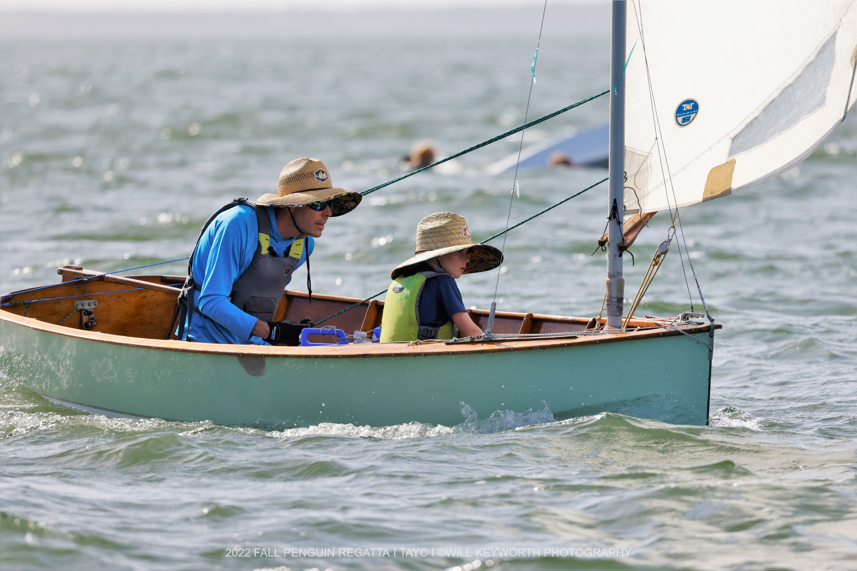
Michael and Henneage Baugh sporting matching hats. A windy day for the 7-yr. old crew. (Photo by Wil Keyworth)
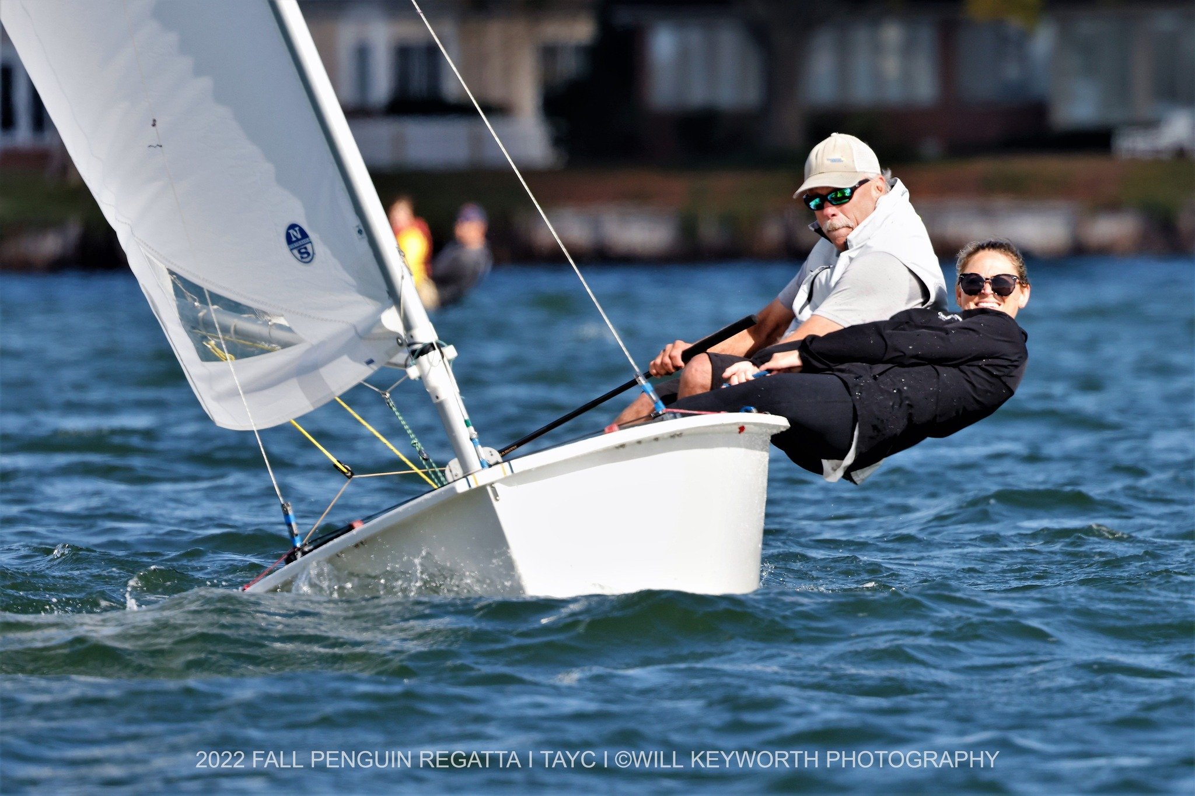
Jonathan and Annie Bartlett surging over a wave on the upwind leg. (Photo by Wil Keyworth)
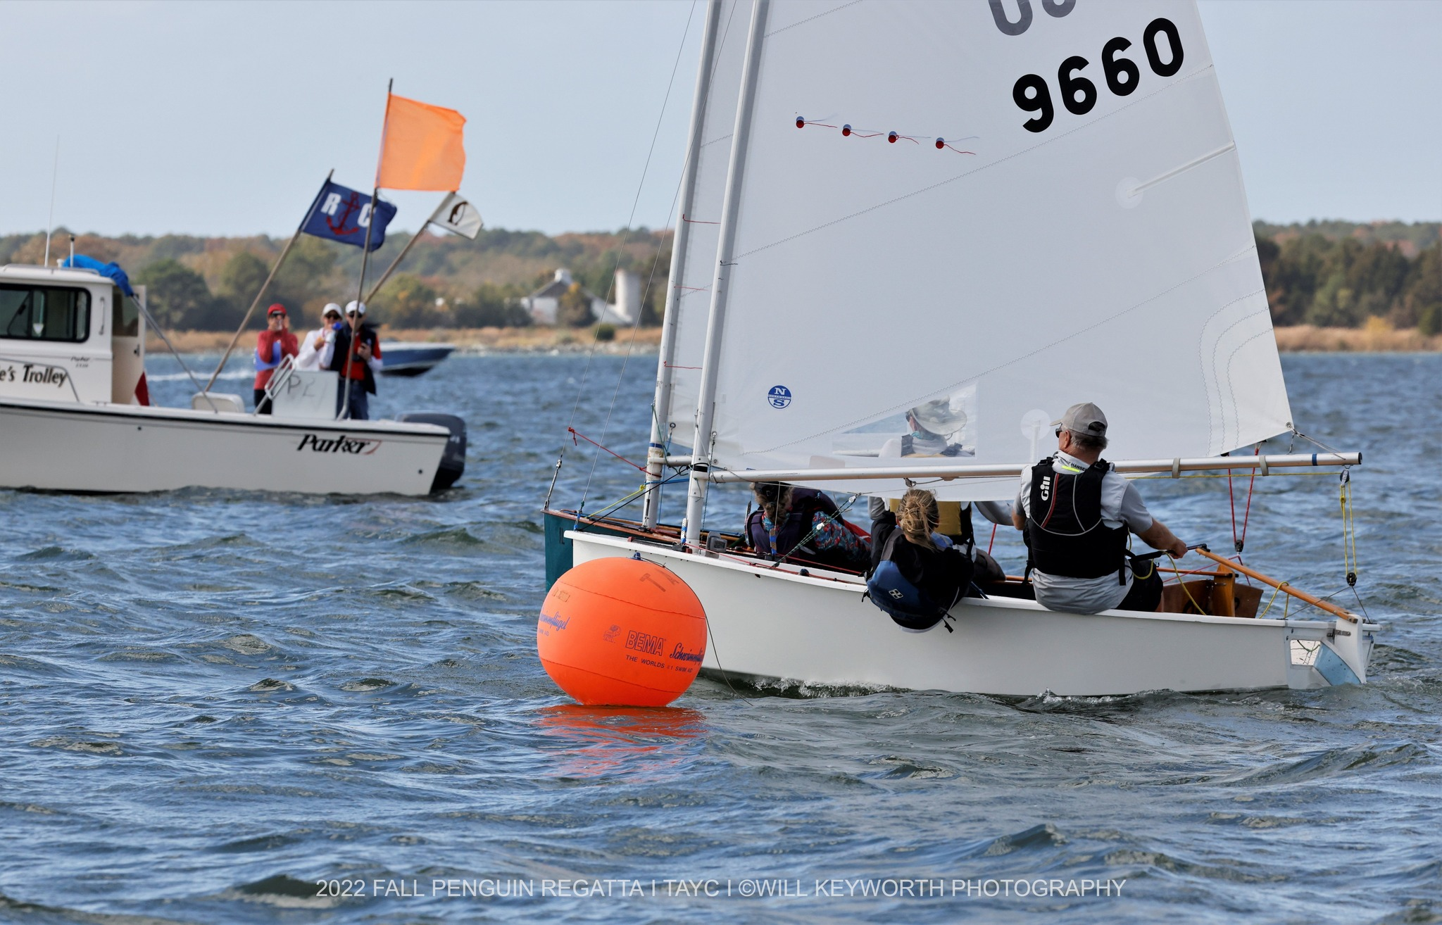
Bartletts and Kraffts in photo finish for race 3. Jonathan got this one, by a sliver of white. (Photo by Wil Keyworth.)
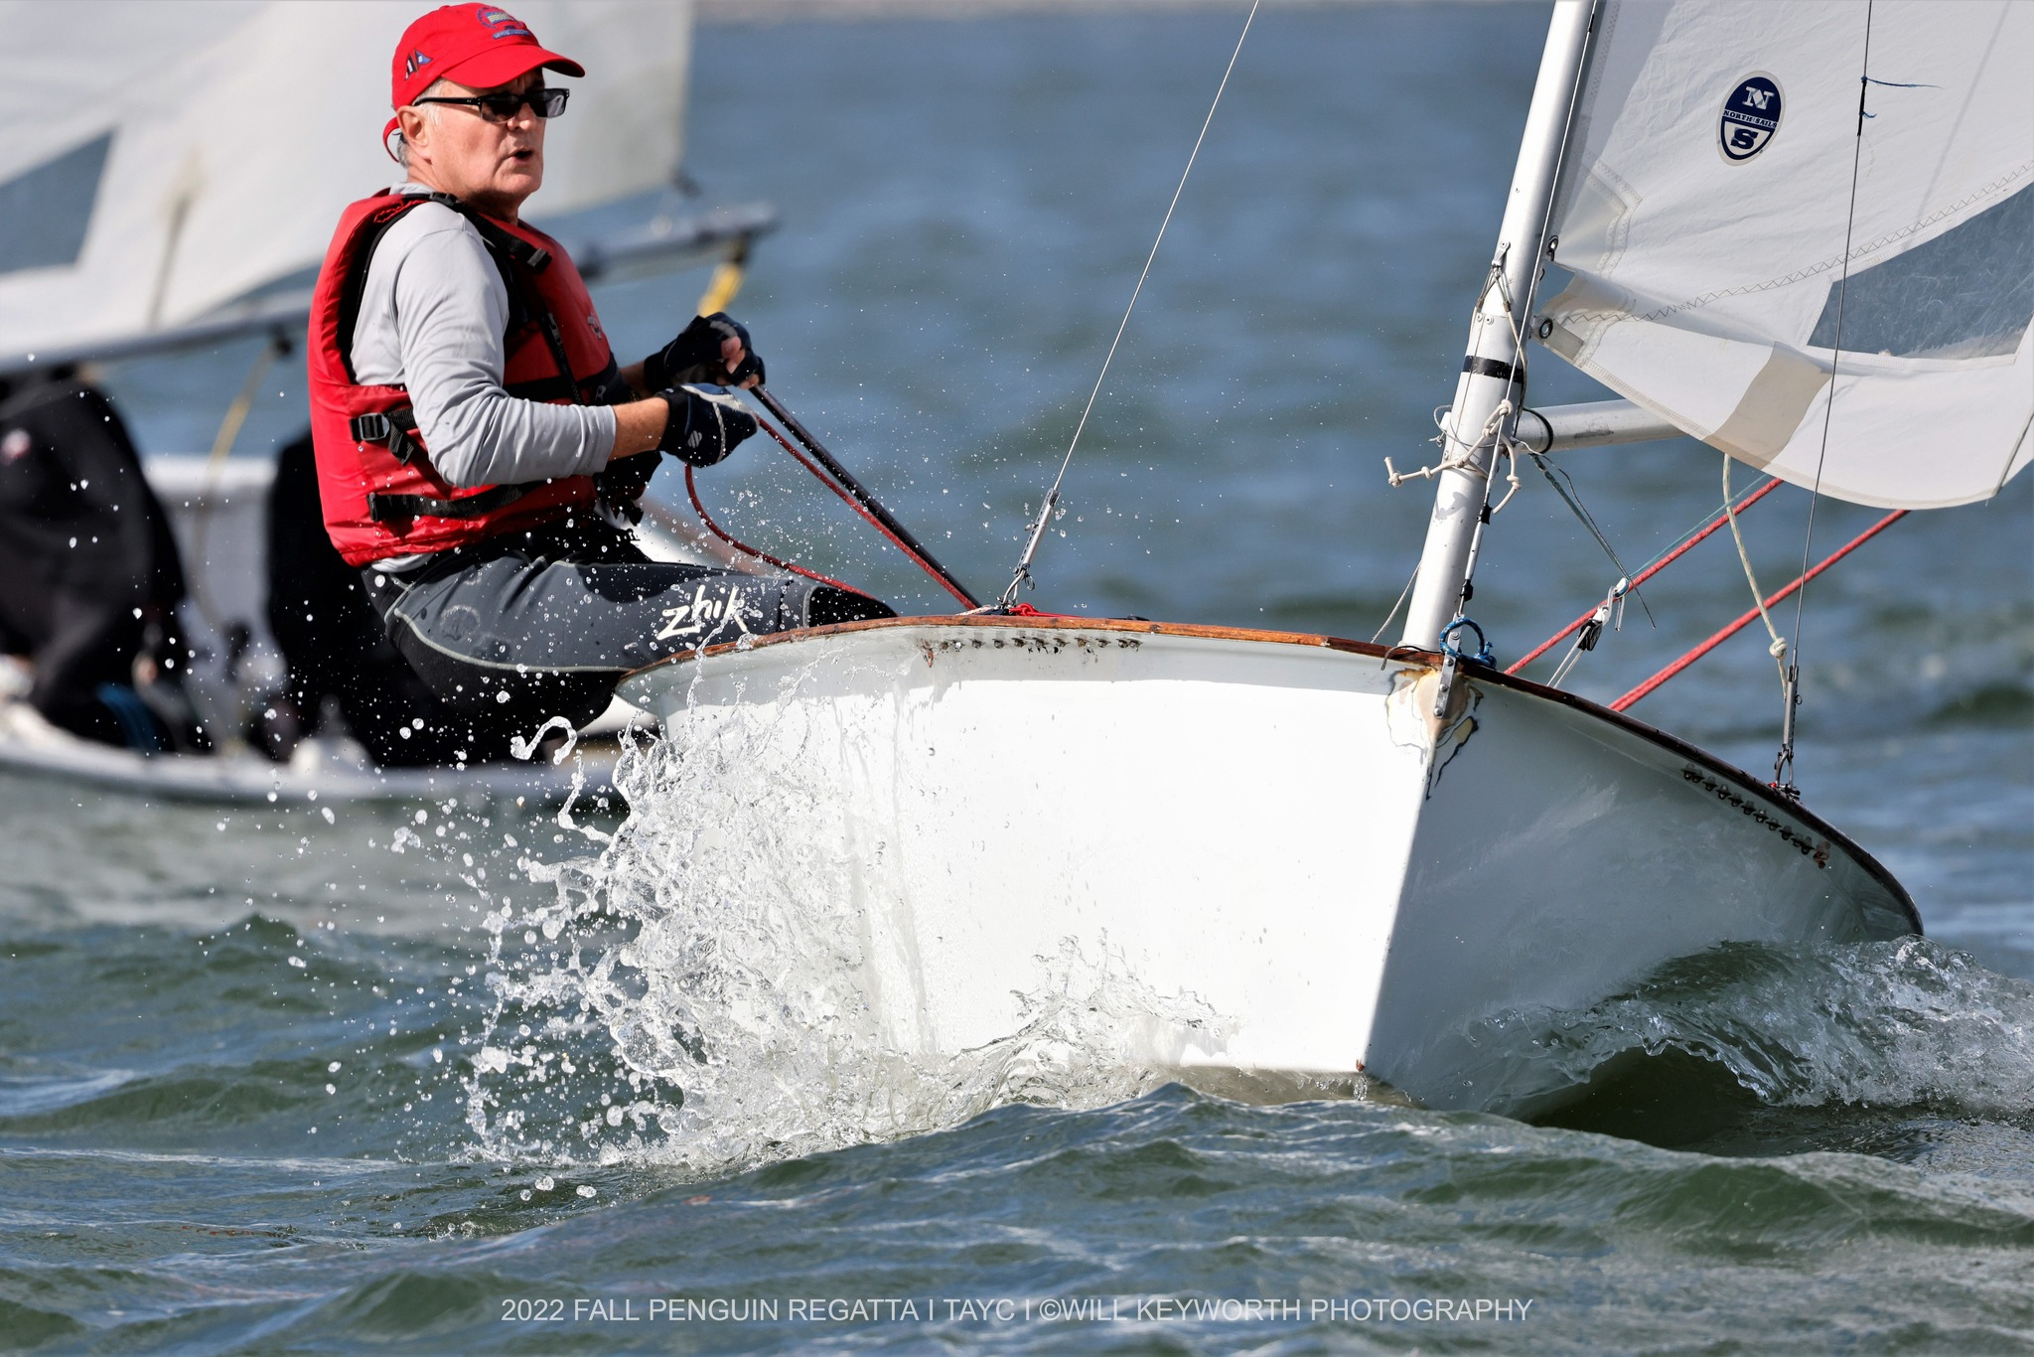
Philip Logan handling the breezy conditions. (Photo by Wil Keyworth.)
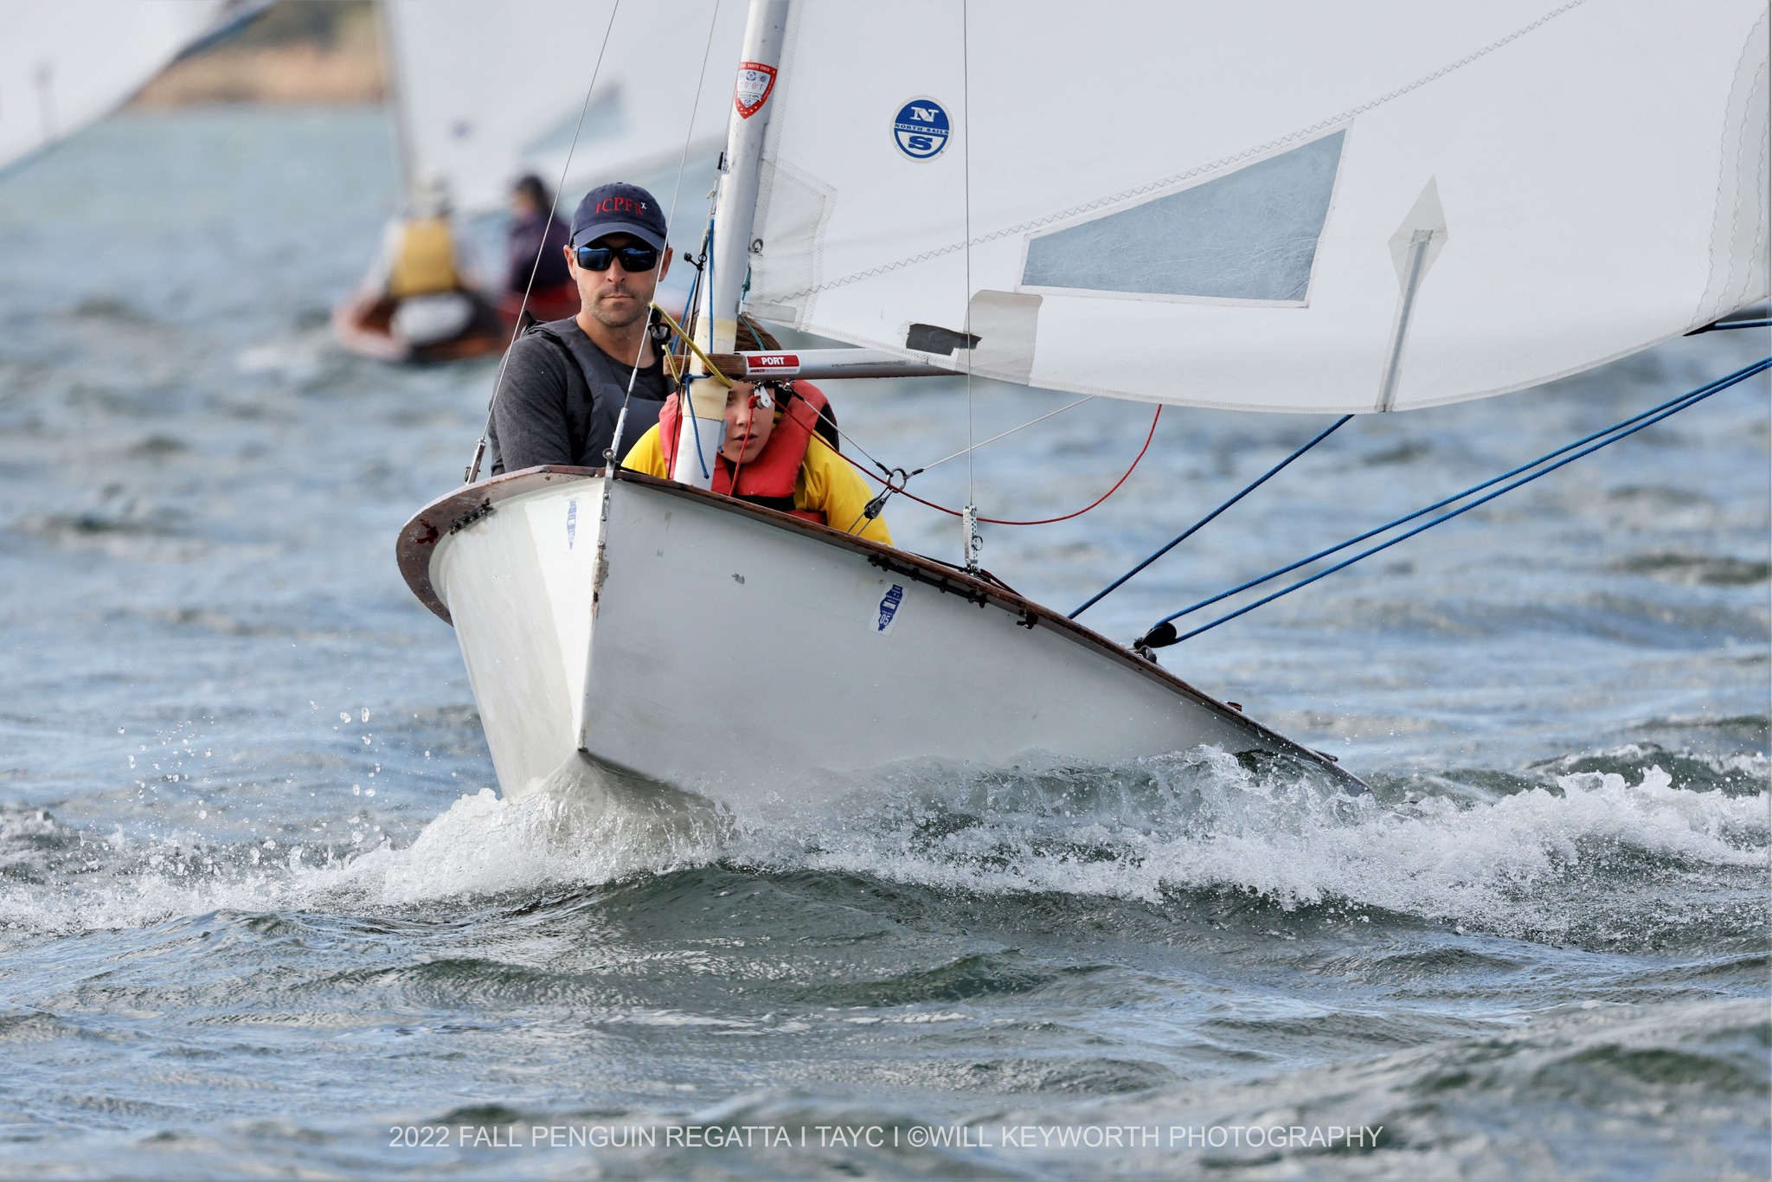
Jeff and Ian Cox (Photo by Wil Keyworth)
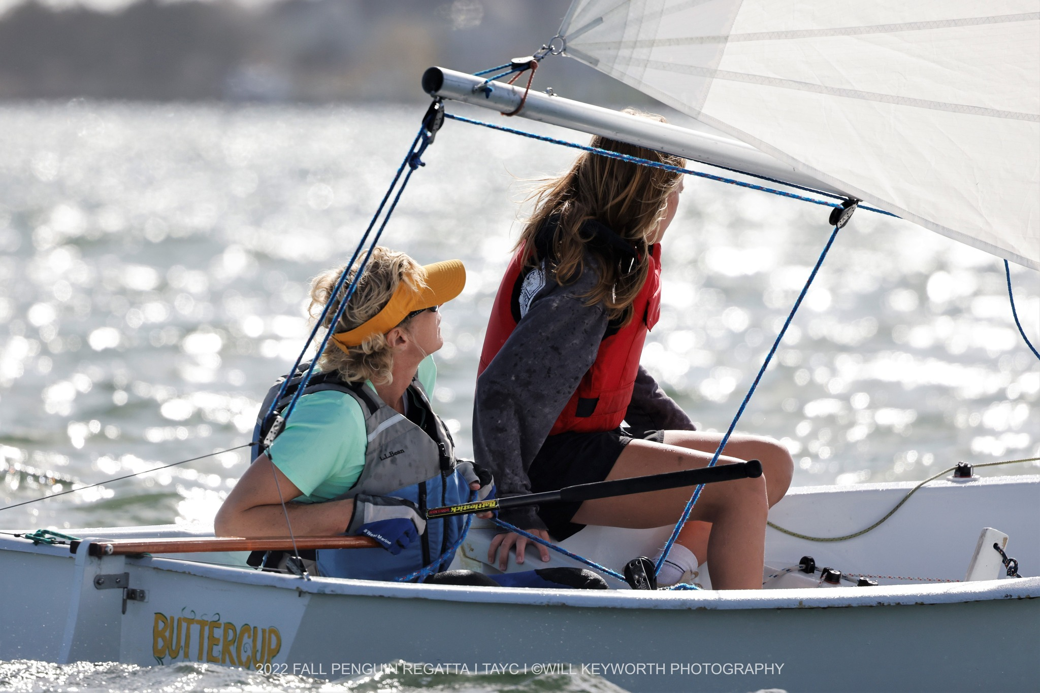
Elizabeth Principe and Lia Schutt sailing upwind in Buttercup. (Photo by Wil Keyworth.)
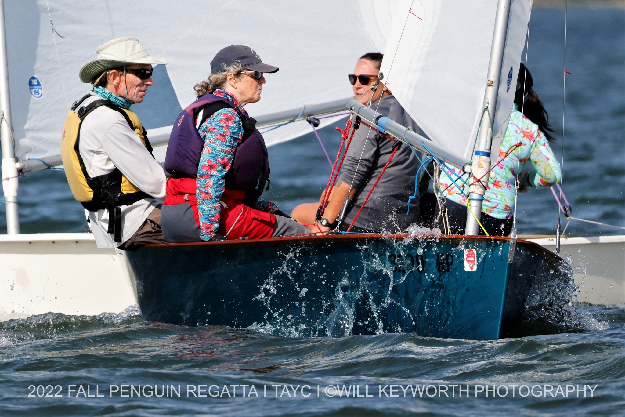
Cairn and Charlie crossing tacks with Jane and Sewall. (Photo by Wil Keyworth)

